NXP4330 Movie Player Example Application for Linux Version 0.9.0

Version 0.8.0
Copyright © 2014 Nexell Co.,Ltd. All rights reserved.
NXP4330 Movie Player Example Application for Linux
Nexell S/W Team 3
Release information
The following changes have been make to this document.
Change History
Date | Change
16 January 2014 | First release for v0.8.0

Proprietary Notice
Information in this document is provided solely to enable system and software implementers to use Nexell products. There are no express or implied copyright licenses granted hereunder to design or fabricate any integrated circuits or integrated circuits based on the information in this document.
Nexell reserves the right to make changes without further notice to any products herein.
Nexell makes no warranty, representation or guarantee regarding the suitability of its products for any particular purpose, nor does Nexell assume any liability arising out of the application or use of any product or circuit, and specifically disclaims any and all liability, including without limitation consequential or incidental damages. “Typical” parameters which may be provided in Nexell data sheets and/or specifications can and do vary in different applications and actual performance may vary over time. All operating parameters, including “Typicals” must be validated for each customer application by customer’s technical experts. Nexell does not convey any license under its patent rights nor the rights of others. Nexell products are not designed, intended, or authorized for use as components in systems intended for surgical implant into the body, or other applications intended to support or sustain life, or for any other application in which the failure of the Nexell product could create a situation where personal injury or death may occur. Should Buyer purchase or use Nexell products for any such unintended or unauthorized application, Buyer shall indemnify and hold Nexell and its officers, employees, subsidiaries, affiliates, and distributors harmless against all claims, costs, damages, and expenses, and reasonable attorney fees arising out of, directly or indirectly, any claim of personal injury or death associated with such unintended or unauthorized use, even if such claim alleges that Nexell was negligent regarding the design or manufacture of the part.

Copyrightⓒ 2009~2014 Nexell Co.,Ltd. All rights reserved.
No part of this publication may be reproduced, stored in a retrieval system, or transmitted in any form or by any means, electric or mechanical, by photocopying, recording, or otherwise, without the prior written consent of Nexell.

Contact us
[463-825] Bundang Yemizi Bldg. 1202, 6-5 Sunae-dong, Bundang-gu, Sungnam-city, Gyeonggi-do, Korea.
TEL: 82-31-698-7400
FAX:82-31-698-7455
http://www.nexell.co.kr

Contents
Chap 1. Overview 2
1.1 Overview 2
1.2 Environment 2
Chap 2. Environment Set 3
2.1 Overview 3
2.2 Library make 3
2.3 Modules make 3
2.4 Gstreamer Plugin 4
2.5 Example Application 4
Chap 3. Example 5
3.1 Bolck Diagram 5
3.2 Shell Mode Diagram 5
3.3 Commands 7
Chap 4. Annex 8
4.1 Annex A(informative) 8

Overview

Overview
이 문서는 NXP4330 Linux 환경에서 각종 동영상 및 음악 파일을 재생하기 위한 Movie Player API를 사용하여 Example Application의 설명한 문서이다.

Environment
이 Example Application의 동작 환경은 다음과 같다.
- NXP4330 D/Q
- Linux Kernel Version 3.4.5+
- G-Streamer 0.10 Plug-In 포함된 root file system.
- G-Streamer video decoder plug-In
  - “libgstnxvideodec.so”
- G-Streamer video sink Plug-In
  - “libgstnxvideosink.so”
- Video en/decoder firmware & library.
  - “nx_vpu.ko”
  - “libnxvpu.so”
- ION memory allocator library.
  - “libnxvmem.so”
- V4L2 device driver & related libraries.
  - “libnxv4l2.so”
  - “libnxdsp.so”
- Movie Player library.
  - “libnxmovplayer.so”
- typefind library.
  - “libnxtypefind.so”

Environment Set

Overview
이부분은 movie player 를 실행하기 위한 환경설정에 관한 내용이다.

Library make

- Build.env 에서 KERNDIR := /home/ray/devel/android/jb-mr1.1/kernel/ 이부분을 kernel 경로에 맞게 설정한다.
- Build.env 에서 ARCHDIR := /home/ray/devel/$(ARCHNAME) 이부분을 linux 경로에 맞게 설정한다. (ex: jb-mr1.1/hardware/nexell/pyrope/linux)
- /linux/library/libion/ 폴더로 이동해서 make;make install 명령어을 실행하면,/linux/ library/ 에include, lib 폴더가 만들어지면서, .h, .so, .a 파일이 복사된다.
- /linux/library/libnxmovieplayer/app_env.mk 파일에서 TOOL_SYS_ROOT := /opt/crosstools/arm-cortex_a9-eabi-4.7-eglibc-2.18/arm-cortex_a9-linux-gnueabi/sysroot 이부분을 툴체인 경로에 맞게 설정한다.
- /linux/library/libnxmovieplayer, libnxv4l2, libnxvpu, libnxtypefind 각각폴더로 이동해서 make;make install 명령어을 실행한다.
- /linux/library/lib/ 폴더에 있는 *.so 파일을 root-file-system rootfs/usr/lib 폴더로 복사한다.

Modules make
- /linux/modules/coda960 으로 이동해서 make file 에서
KDIR := /home/ray/devel/android/jb-mr1.1/kernel 이부분을 kernel 경로에 맞게 설정한다.
- make ARCH=arm 을 실행하면 nx_vpu.ko 파일이 만들어진다.
- nx_vpu.ko 을 root-file-system rootfs/root/ 복사한다.
- 리눅스가 부팅되면 insmod nx_vpu.ko 명령어을 실행한다.

Gstreamer Plugin
- linux/library/lib/gstreamer-0.10/libgstnxvideodecoder.so, libgstnxvideosink.so 파일을 root-file-system rootfs/usr/lib/ /gstreamer-0.10/ 폴더로 복사한다.

Example Application
- /linux/apps/movie_player_app/ 폴더에서 make 명령어를 실행한다.

Example

Bolck Diagram

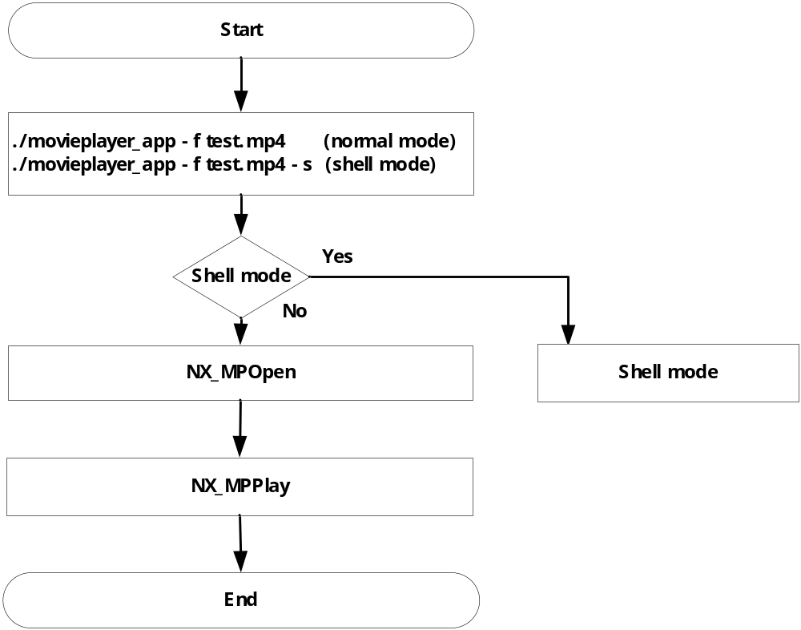 그림1. Example Block Diagram
그림1은 example 에 대한 설명이다.
- movieplayer_app –f test.mp4 명령어를 실행하면 기본적인 플레이가 된다.
- movieplayer_app –f test.mp4 –s 명령어를 실행하면 Shell mode 가 실행되어 원하는 Commands 을 실행할수 있다.

Shell Mode Diagram

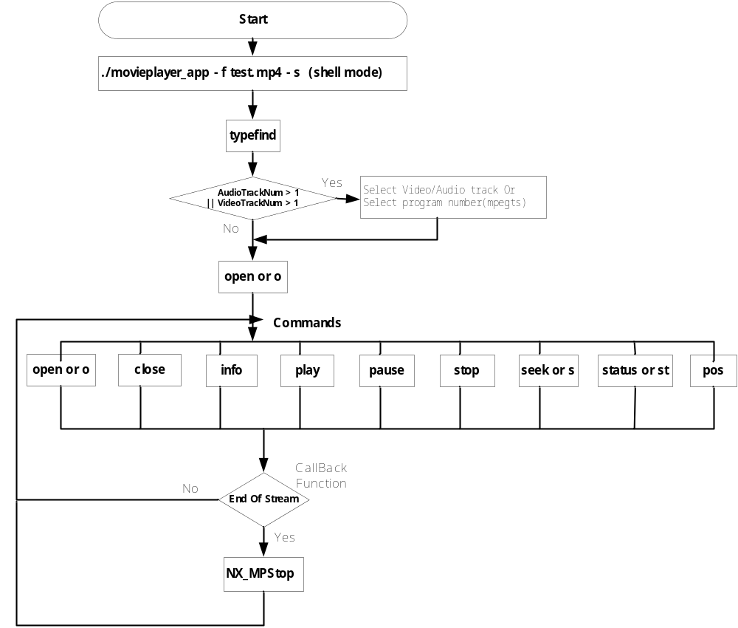
그림 2. Shell Mode Diagram 1
그림 2는 shell mode에 대한 설명이다.
- movieplayer_app –f test.mp4 –s 명령어 를 실행한다.
- Command(typefind) 를 실행한다.
  - video track 이 1개 이상이면 원하는 track 을 선택한다.
  - audio track 이 1개 이상이면 원하는 track 을 선택한다.
  - Mpegts file 인 경우 program 이 1개 이상이면 원하는 program number 를 선택한다.
- Command(open or o) 를 실행한다.
- Command(play) 를 실행한다.
- 원하는Command(close, info, pause,stop,seek,status,pos) 를 실행한다.
- file에서 더 이상 읽어올 데이터가 없으면 Callback function 을 통해 CALLBACK_MSG_EOS 를 발생시킨다.
- CALLBACK_MSG_EOS 발생하면 stop 을 실행한다.
- 원하는 Command 를 실행한다.

Commands

Commands | Function
open or o | open player for specific file
close | close player
info | show file informationc
play | Play
pause | Pause playing
stop | stop playing
seek or s | Seek (ex: s 50000)
status or st | Display current player status
p | Toggle play & pause
pos | Change play position (ex: pos 0 0 30 30 720 480)
vol | Change volume (ex: vol 50)
typefind | File information

Annex

Annex A(informative)

Change history
Change history
Date | Subject/Comment | Old | New
2014-03 | 1. Add Container Type MPEG-TS | 0.9.0 | 0.9.1
2014-03 | 1. Add command typefind  2. Add Video/Audio Track Select(in case multitrack) | 0.8.0 | 0.9.0
2014-02 | Movie Player Example Aoolication for Linux |  | 0.8.0

